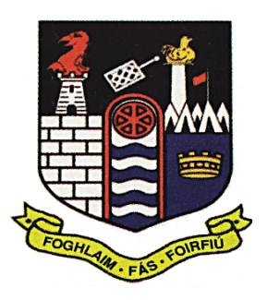**C**oláiste Mhuire

An Muileann gCearr

**Telephone 044 9344743 Email: reception@cbsmullingar.ie Website:** [**www.cbsmullingar.ie**](http://www.cbsmullingar.ie)

**Coláiste Mhuire celebrates yet another fantastic year of Academic Success on Leaving Cert Results Day!**

Coláiste Mhuire Secondary School is delighted to congratulate all of its graduating students as they receive their Leaving Certificate results today. This milestone marks the culmination of years of hard work, dedication, and resilience, and we are immensely proud of each and every student.

We extend our sincere gratitude to the parents, guardians, and families who have supported and encouraged our students throughout their school journey. We also wish to acknowledge the commitment and care shown by our teachers, whose guidance and encouragement have been central to today’s success.

While exam results are an important stepping stone, we remind our students that results do not define any person. Each student is valued for their unique strengths, talents, and character, and today represents just one part of their personal and educational journey.

We are fortunate to have an excellent Career Guidance Department who have worked tirelessly to ensure that all students are well-prepared for the next stage of their lives. Whether choosing university, apprenticeships, further education, or other career pathways, our students leave with multiple options and the confidence to make informed choices.

Speaking on behalf of the school community, our School Principal Keith Quinn said:  
“We are immensely proud and privileged to have worked with these students and their families over the past number of years. Today is a celebration of their achievements, but also of their growth as young men ready to take the next step in their journey. We wish them every success in the future.”

He continued that “Coláiste Mhuire celebrates not only the academic achievements of the Class of 2025, which have again this year been well above the national norms, but also their contributions to school life which have been immense and have included many accolades which will leave a wonderful legacy for the generations of our school community to build upon”.

Over 150 students received their Leaving Certificate results today with many joining their teachers in the school to celebrate this milestone occasion.

22.08.2025

*Further details will be available on our social media platforms.*