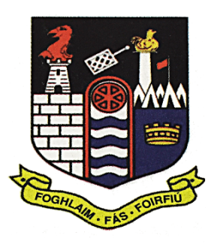
Coláiste Mhuire
An Muileann gCearr

Telephone 044 9344743 Email: reception@cbsmullingar.ie Website: www.cbsmullingar.ie

Coláiste Mhuire Celebrates Another Outstanding Year of Academic Success on Leaving Cert Results Day!

Coláiste Mhuire Secondary School is celebrating another exceptional year of Leaving Certificate results, as more than 160 students from the Class of 2026 received their results on Friday.
Students returned to the school to celebrate this important milestone with their classmates, with many of their teachers and staff present to share this special moment with them. Once again, results achieved by Coláiste Mhuire students were well above national norms, reflecting the hard work, commitment and resilience shown by the year group throughout their time in the school.
The Class of 2026 leaves Coláiste Mhuire having made an outstanding contribution to school life. Alongside their academic achievements, students distinguished themselves through leadership, sport, music, student voice and involvement in the wider school community. These students also played a central role in one of the most significant achievements in the school’s history; Coláiste Mhuire’s first All-Ireland Hogan Cup success.
Principal Keith Quinn congratulated the students on their achievements:
“Today is a day of great pride for our students, their families and our entire school community. We are delighted with the exceptional results achieved by the Class of 2026, but equally proud of the young men behind those results and the contribution they have made to Coláiste Mhuire.
“The dedication shown by the members of the Class of 2026 who were part of Coláiste Mhuire’s historic Hogan Cup winning campaign is particularly worthy of recognition. Balancing the demands of elite schools football with Leaving Certificate year required enormous commitment and discipline. Their exceptional Leaving Certificate results demonstrate how the values developed through sport - including hard work, resilience, teamwork and performing under pressure - can pay dividends far beyond the playing field.”

Deputy Principal Micheál Lawler added:
“Many of our students now move onto further study in a broad range of areas such as engineering, medicine, zoology, astrophysics, commerce, teaching, nursing. Some students have already begun apprenticeship programmes as electricians, plumbers and in local engineering companies where they will combine their studies with practical work experience. Many have already received scholarships for their involvement with student council, STEM, music & sport. The range of interests, opportunities and avenues being explored is incredible.”
The school also paid tribute to the parents, guardians and families who supported students throughout their secondary education and to the teachers and staff whose dedication, care and professionalism helped students to achieve their absolute potential.
While Results Day is an important milestone, Coláiste Mhuire recognises that there are many pathways to future success. The school’s Guidance Team will continue to support students as they consider CAO offers and opportunities in higher and further education, apprenticeships, training and employment.
As the Class of 2026 prepares for the next chapter of their lives, the entire Coláiste Mhuire community extends its warmest congratulations and best wishes to each of its students for the future.
‘Congratulations to the Class of 2026 - we are immensely proud of all that you have achieved, and we wish you every success in the exciting journey ahead!’

21.08.2026
Further details are available from Coláiste Mhuire, Mullingar.

