Cornell Note Taking Method Active Learning

This can be used as a method of recording notes in class or next year at college for note taking at lectures.

OR

It can be used to condense chapters or sections of chapters from your textbooks into short manageable notes for revision.
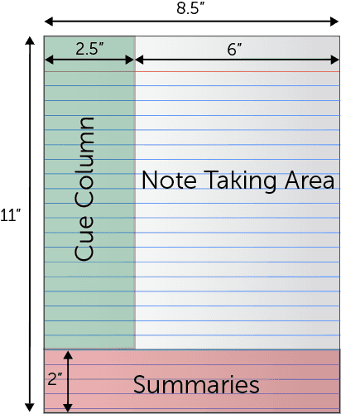
Note Taking Area: Record lecture or chapter as fully and as meaningfully as possible.
Cue Column: As you are taking notes, keep cue column empty.
Then after the lecture or after going through the chapter, reduce your notes to concise jottings in the cue column and use the cue column as clues for Reciting, Reviewing, and Reflecting or for prompts for Blurting.
Summaries: At the bottom of the page sum up each page of your notes in a sentence or two.
This format provides the perfect opportunity for following through with the 5 R's of note-taking:
- Record
During the lecture or when going over a chapter, record in the main column as many meaningful facts and ideas as you can. Write legibly.
- Reduce
As soon after as possible, summarize these facts and ideas concisely in the Cue Column. Summarizing clarifies meanings and relationships, reinforces continuity, and strengthens memory.
- Recite
Cover the Note Taking Area, using only your jottings in the Cue Column, say over the facts and ideas from the chapter or the lecture as fully as you can, not mechanically, but in your own words. (Aloud is good) Then, verify what you have said. Some people prefer to write the ideas down (briefly) and check them.
- Reflect
Draw out opinions from your notes and use them as a starting point for your own reflections on the section and how it relates to your other sections of the course. Reflection will help prevent ideas from being inert and soon forgotten.
- Review
Spend 10 minutes every week in quick review of your notes, and you will retain most of what you have learned. You can use the Blurting method for this.

